# Overview of consolidated Technical Specification

Table of Contents

Technical Specification 1

1. Requirement Details 6

1.1 Summary of Requirements 6

1.2 Functional / Business description 6

1.3 Design Alternative (Mandatory) 6

1.4 Process Flow Diagram < User Interaction with the system in detailed> (Mandatory) 6

1.5 Peer Review 6

2. Reports/Layouts 7

2.1 Input/Selection screen parameters 7

2.2 Output Format for Reports/Layouts 7

3. Layouts (Additional info) 8

3.1 Printing Existing solutions 8

3.2 New Layout Requirements 8

4. User Exit / Enhancement Details 9

5. Business Add-in (BADI) 10

6. Module Pools 11

Screen Flow Diagram 11

List of screens 11

7. Other Development Objects 12

8. Custom / Z tables 13

9. Interfaces 14

10. Development Logic 15

11. Security [Mandatory] 16

12. Message handling 17

13. Impact Analysis: [Mandatory for all changes] 18

13.1 Impact on processes including application controls: No Impact 18

13.2 Impact on data: No Impact 18

13.3 Impact on end users: No Impact 18

13.4 Impact on Interfaces with other systems: No Impact 18

13.5 Impact on Operational procedures: No Impact 18

13.6 Impact on Infrastructure: No Impact 18

13.7 Impact on System / DB Admin: No Impact 18

14. Test cases (State reasons if any of the testing is not applicable) 19

14.1 Unit testing: 19

14.2 Integration testing: 19

14.3 Interface testing: 19

14.4 Volume/ Stress testing: 19

14.5 Security testing: 19

14.6 Data conversion testing: 19

15. Deployment Plan (Applicable for NON SAP application) 20

# Requirement Details

## Summary of Requirements

Triggering of an external mail when Maintenance Notification is created in SAP System and for Notification type M1 and M2 only:

* Implemented BADI (**NOTIF_EVENT_SAVE**), Upon Saving the **M1** and **M2** Notification Notify the responsible maintenance team through an E-mail.
* This method (**CHANGE_DATA_AT_SAVE**) contain all the business logic.
* Email Address – Create a new field (SMTP_ADRR) in the ZTPM_USERS table. This field will store email id. This field is **MANDATORY.**
* Planner Group – Create a new field (INGRP) in the ZTPM_USERS table. This field is **MANDATORY.**
* Planning Plant– Create a new field (IWERK) in the ZTPM_USERS table. This field will store given by user planning plant. This field is **MANDATORY.**
* Employee ID – Create a new field (EMPID) in the ZTPM_USERS table. This field will store employee ID. This field is **MANDATORY**
* Name – Create a new field (Name) in the ZTPM_USERS table. This field will store Name. This field is **MANDATORY.**
* Mobile No – Create a new field (MOBNO) in the ZTPM_USERS table. This field will store Mobile No. This field is **OPTIONAL.**
* Stat – Create a new field (STAT) in the ZTPM_USERS table. This field will store flag of active or inactive email address. This field is **MANDATORY**

## Functional / Business description

## Design Alternative (Mandatory)

Changing the existing BADI is only option.

## Process Flow Diagram < User Interaction with the system in detailed> (Mandatory)

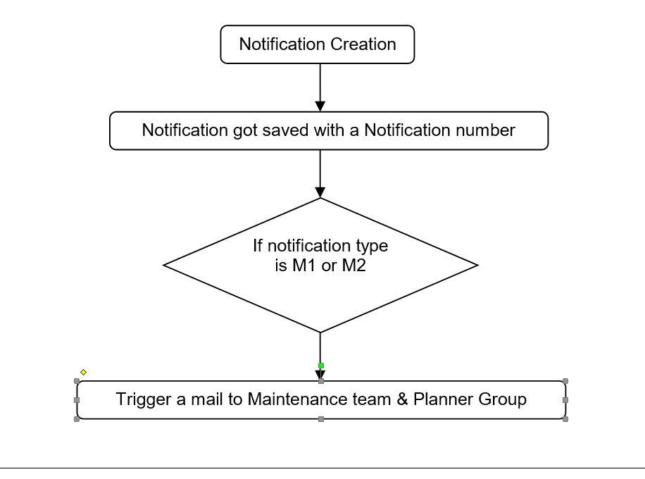

## Peer Review



# Reports/Layouts

## Input/Selection screen parameters

(Provide layout of selection-screen if there are any specific alignment requirements other than standard)

|  |  |  |  |  |  |  |  |  |  |
| --- | --- | --- | --- | --- | --- | --- | --- | --- | --- |
| Table Field Name | Logical grouping of fields within boxes | Input options | | | | Other comments | Default Value | Drop down / Search Help | |
|  |  |  |  |  |  |  |  |  |

## Output Format for Reports/Layouts

NA

# Layouts (Additional info)

## Printing Existing solutions

|  |  |
| --- | --- |
| Output type (Printer) |  |
| Program Name |  |
| Layout Form Name |  |

## New Layout Requirements

|  |  |
| --- | --- |
| Output type (Printer) |  |
| Page Format  (with ref to Page size) |  |
| Orientation (Portrait/Landscape) |  |
| Font |  |
| Font size |  |

# User Exit / Enhancement Details

|  |  |
| --- | --- |
| Enchantement | NA |
| Component / Exit name / Function module | NA |
| Transactions impacted | NA |

# Business Add-in (BADI)

|  |  |
| --- | --- |
| Definition | NOTIF_EVENT_SAVE |
| Method | CHANGE_DATA_AT_SAVE |
| Transactions impacted | IW21 |
| Implementation name | ZBM_NOTIFEVENTSAVE |

# Module Pools

Screen layouts to be provided.

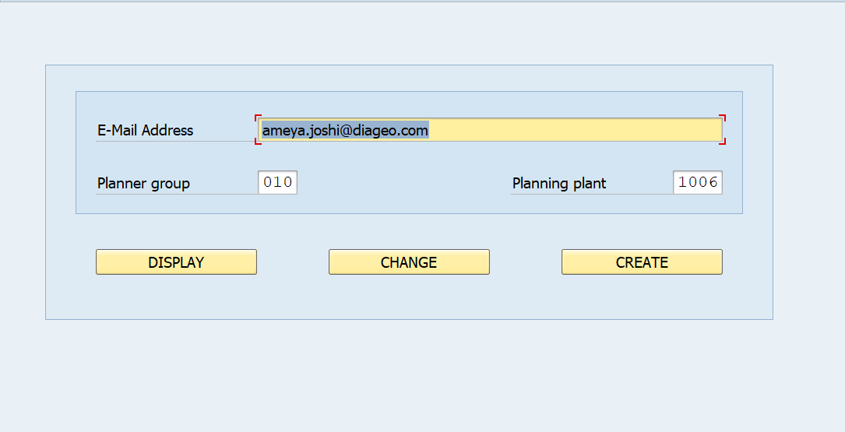

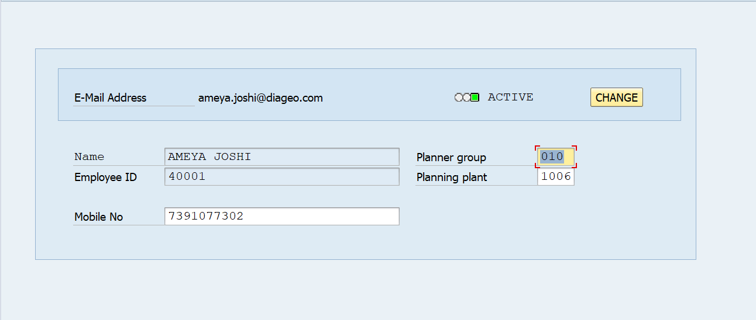

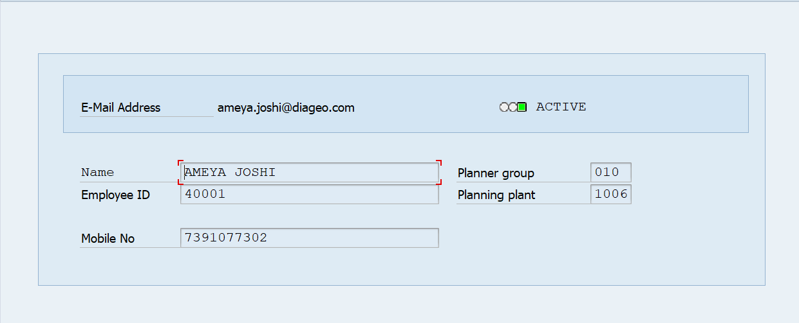

### Screen Flow Diagram

Create

Screen 1001

Change

Screen 1000

Display

### List of screens

|  |  |
| --- | --- |
| Screen no. | Description |
| 1000 | PM Users |
| 1001 | Create, Change, Display PM Users |
|  |  |

# Other Development Objects

All other objects like function modules, Search helps, Field exits, Form exits etc. which have not been classified earlier and which need to be created should be explained here.

|  |
| --- |
| FM Name |
| SO_NEW_DOCUMENT_SEND_API1 |
| ICON_CREATE |

|  |
| --- |
| Class Name |
| NA |

|  |
| --- |
| Include name |
| ZSAPMZPM01_TOP |
| ZSAPMZPM01_F01 |
| ZSAPMZPM01_I01 |
| ZSAPMZPM01_O01 |

# Custom / Z tables

1. **ZTPM_USERS**

|  |  |
| --- | --- |
| Delivery Class | A |
| Table maintenance required | yes |
| TCode for data maintenance | ZPMNU |
| Type of table maintenance |  |

|  |  |  |  |  |
| --- | --- | --- | --- | --- |
| Field Name | Primary key | Data type | Length / Decimal | Field description |
| MANDT |  | CLNT | 3/0 | Client |
| SMTP_ADRR |  | CHAR | 241/0 | E-Mail Address |
| INGRP |  | CHAR | 3/0 | Planner For Plant Maintenance |
| IWERK |  | CHAR | 4/0 | Planning Plant |
| EMPID |  | CHAR | 20/0 | Employee ID |
| NAME |  | CHAR | 30/0 | Name |
| MOBNO |  | NUMC | 11/0 | Mobile NO |
| STAT |  | CHAR | 1/0 | Status Active/Inactive |

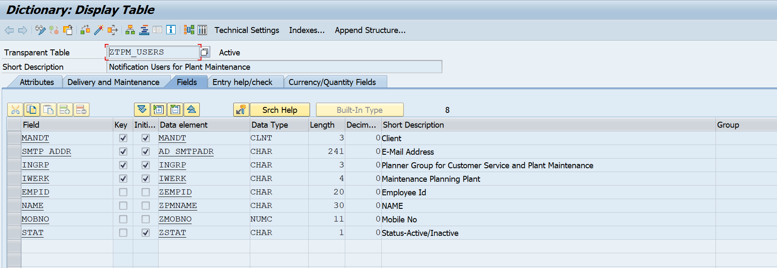

# Interfaces

Write the interface names and the interface type.

# Development Logic

* Created the table ZTPM_USERS with E-Mail Address, Planner Group, Planning Plant, Employee ID, Name, Mobile No, Status-Active/Inactive.

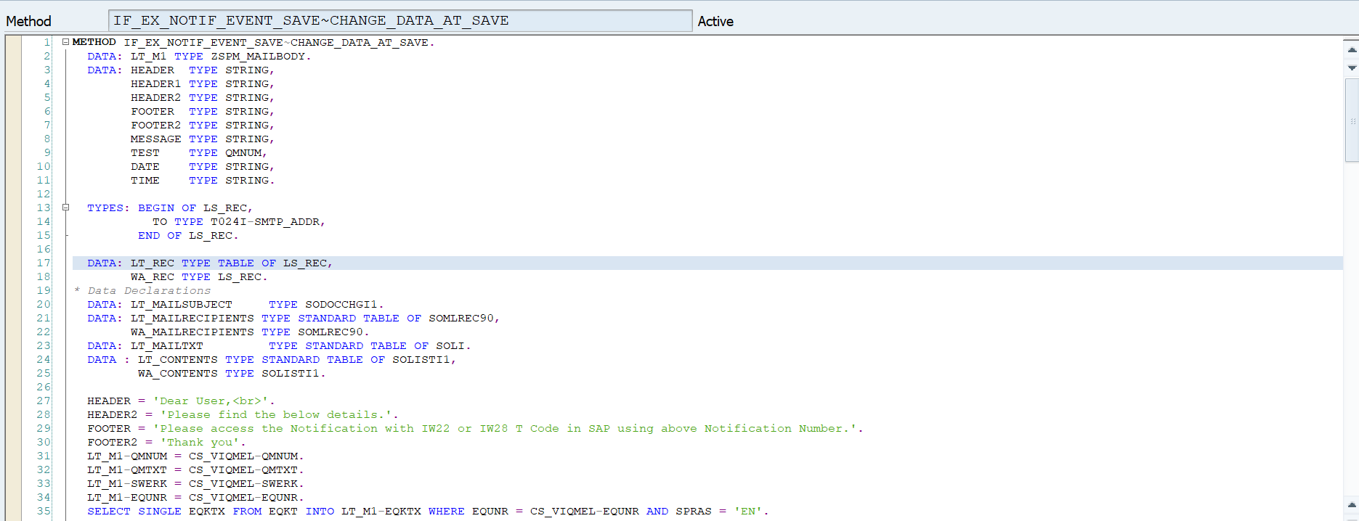

Implementing NOTIF_EVENT_SAVE, whenever user saving the notification this BADI is triggered and it will check notification type is M1 or M2 if yes, SAP System will send mail to its responsible maintenance team.

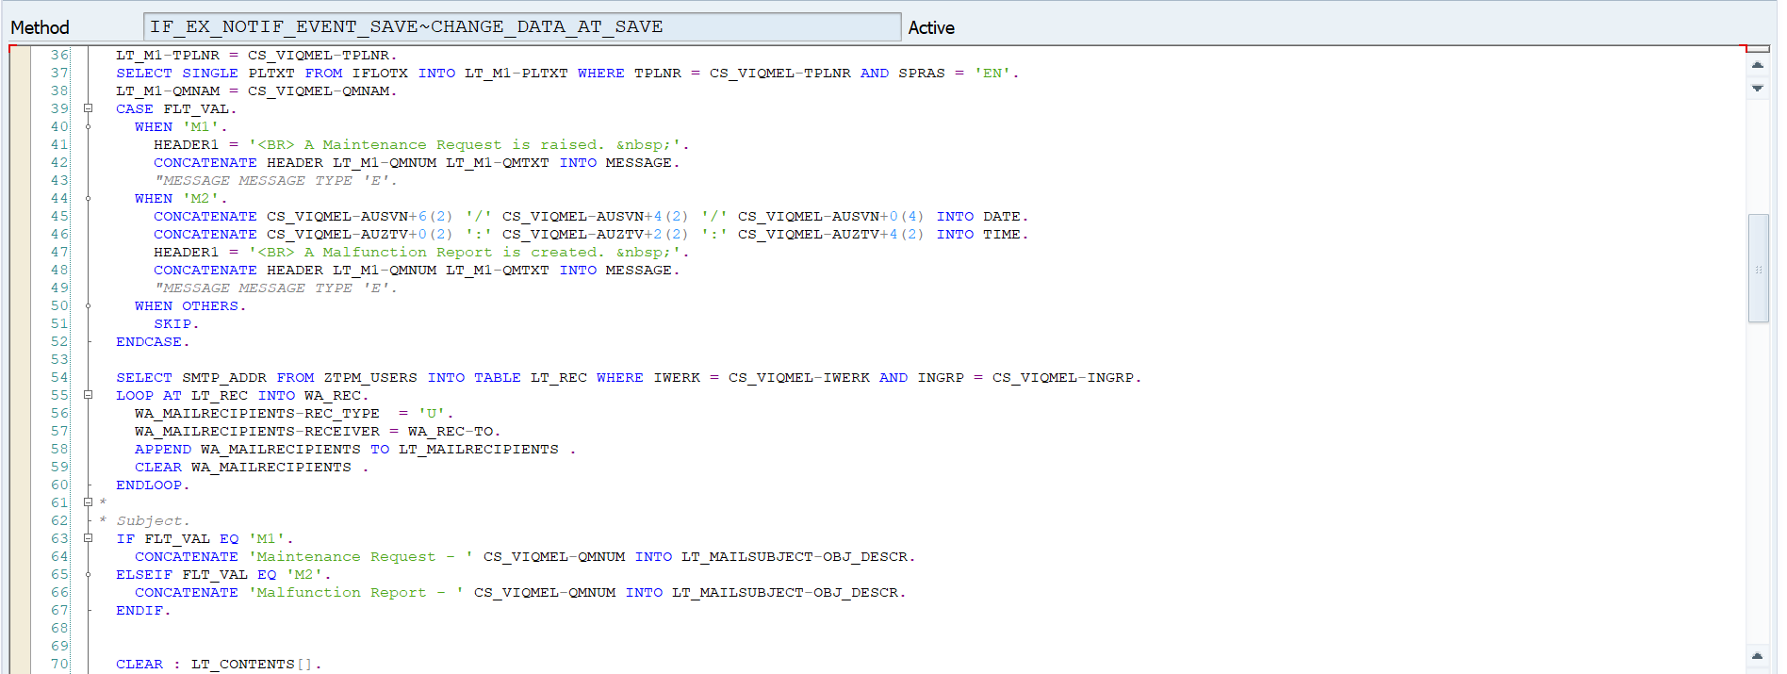

For **M1** Type Notification:

Creating mail contents based on notification number.

Notification Number (QMNUM), Notification Description (QMTXT),

Maintenance Plant (SWERK), Equipment (EQUNR),

Equipment Description (EQKTX), Functional Location (TPLNR):

Functional Location (PLTXT), Reported By (QMNAM),

Breakdown Date & Breakdown Time (AUSVN & AUZTV).

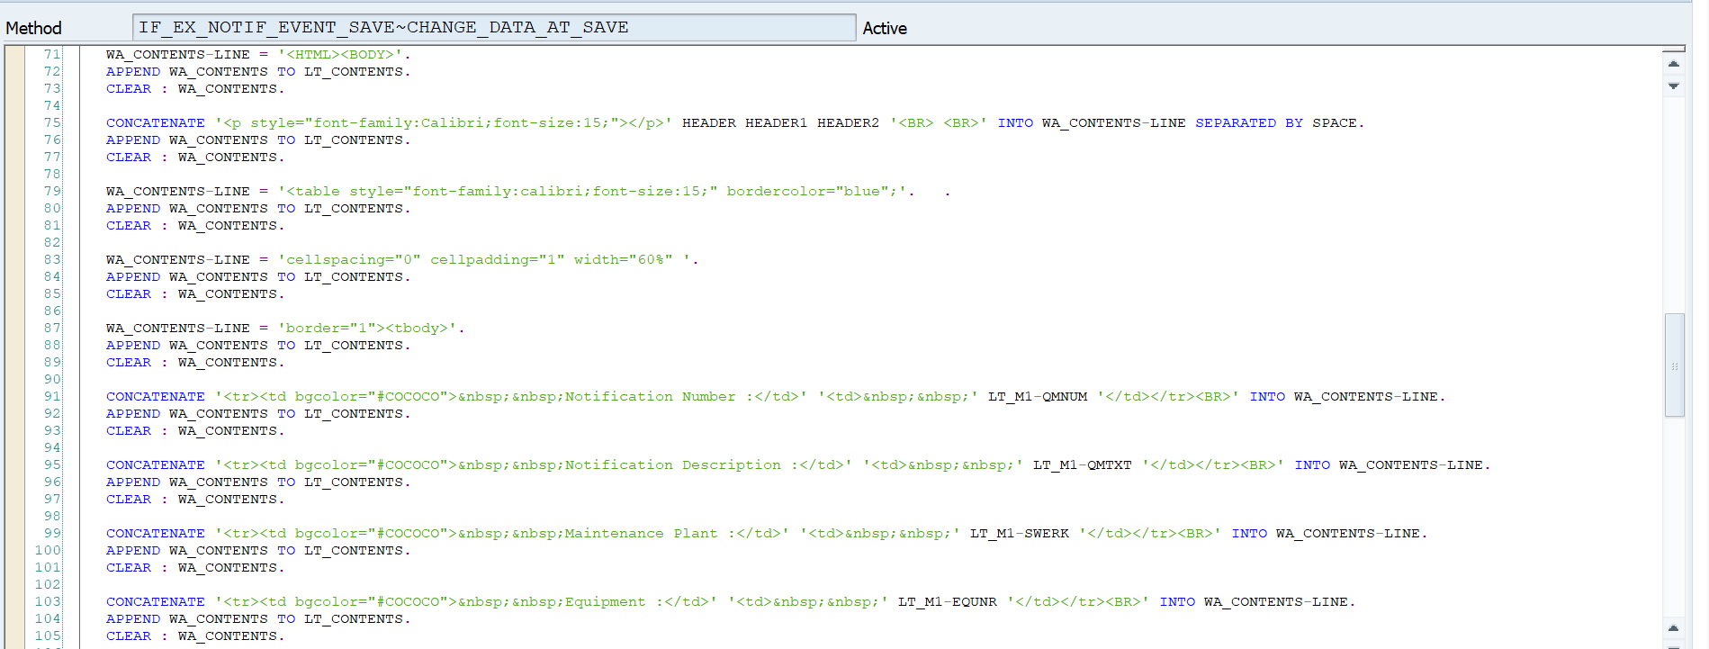

For **M2** Type Notification:

Creating mail contents based on notification number.

Notification Number (QMNUM), Notification Description (QMTXT),

Maintenance Plant (SWERK), Equipment (EQUNR),

Equipment Description (EQKTX), Functional Location (TPLNR):

Functional Location (PLTXT), Reported By (QMNAM).



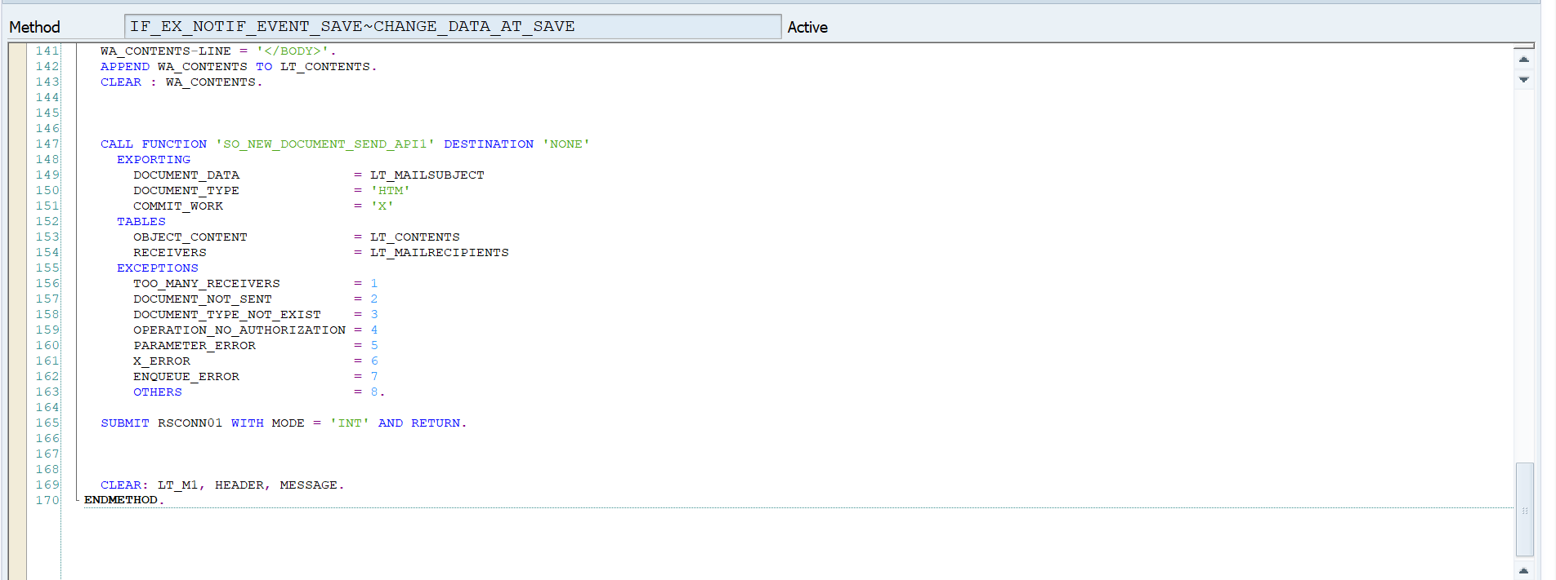

* In check method, if the email id does not contains ‘DIAGEO.COM’ for mail id it will give an error message.
* Business logic to add PM users in SAP ZTPM_USERS custom table using pool program.

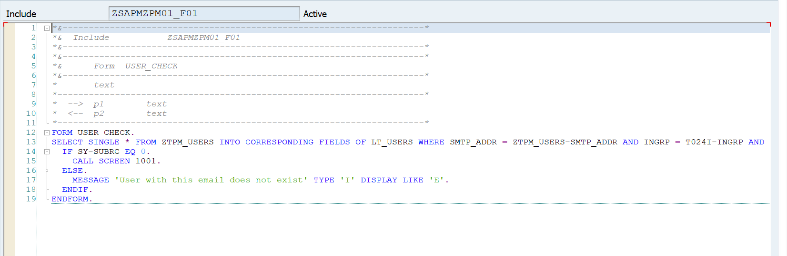

* Checking user is exist or not in SAP system.

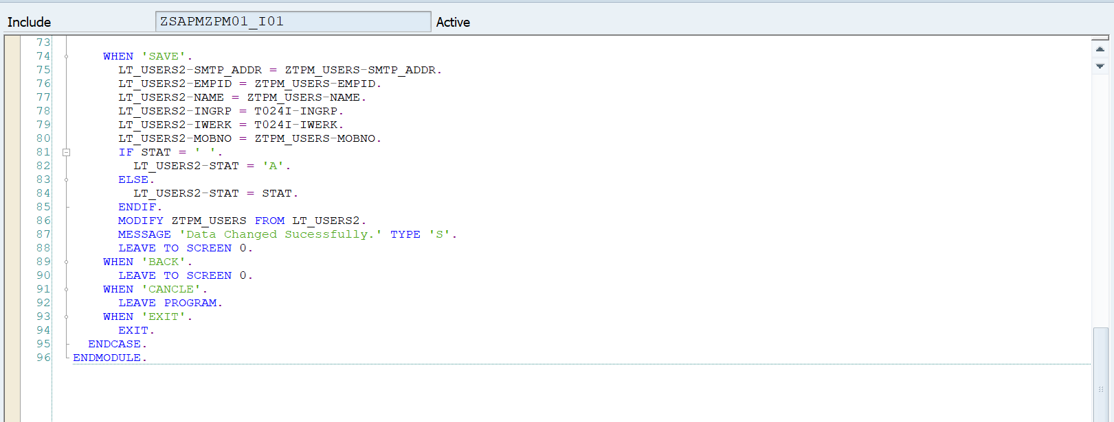

* Action on SAVE button, provided data will be saved in database.

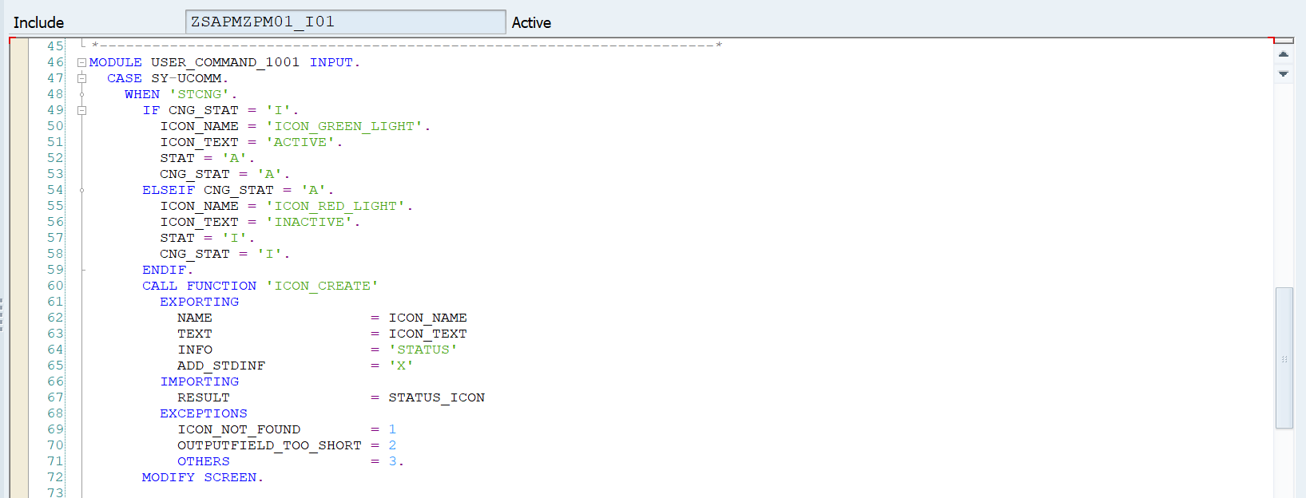

* Check mail status active/inactive. (Active – Green Light, Inactive – Red Light)
* Below code PAI and PBO of 1000 and 1001 screen.

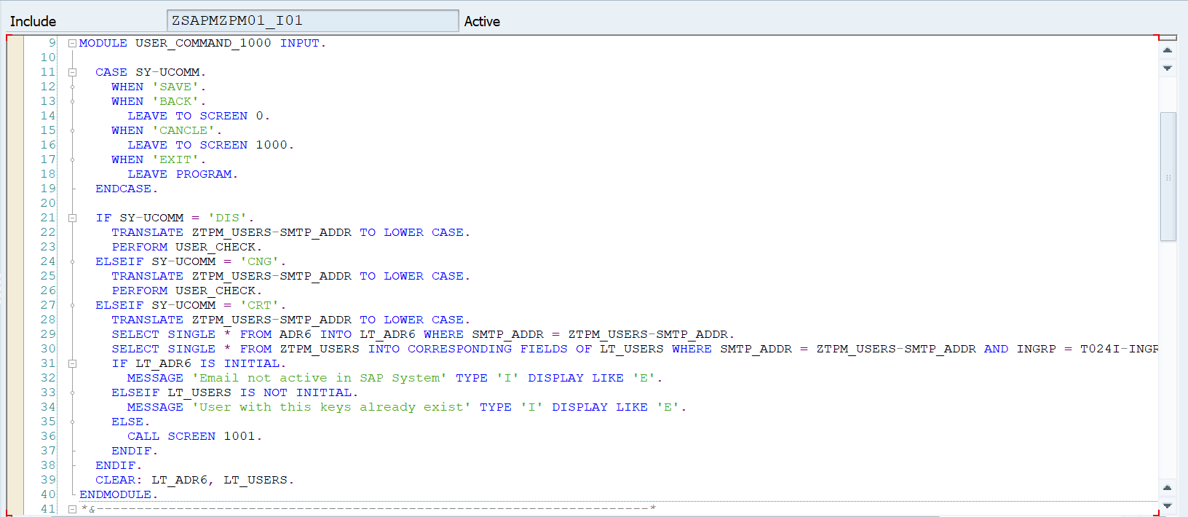

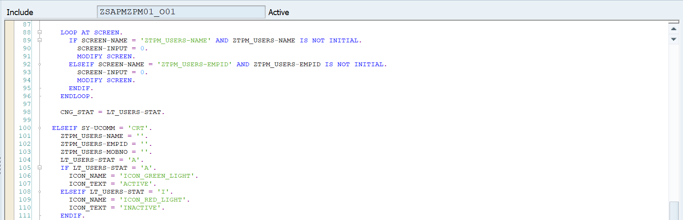

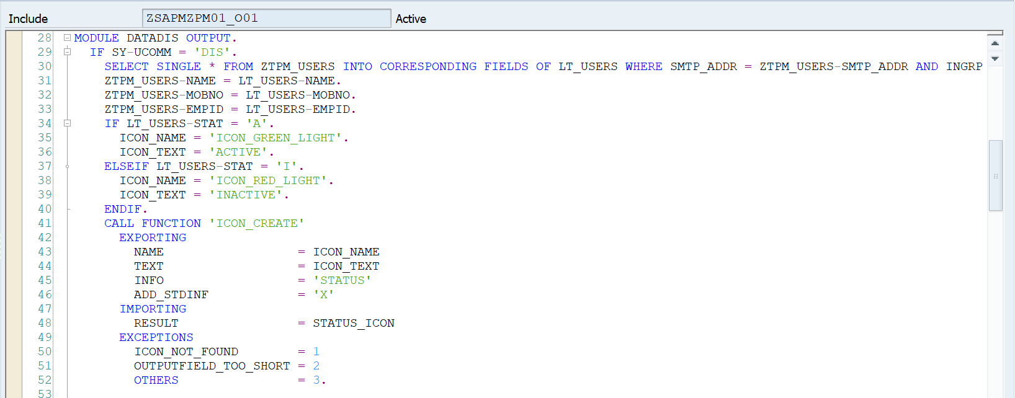

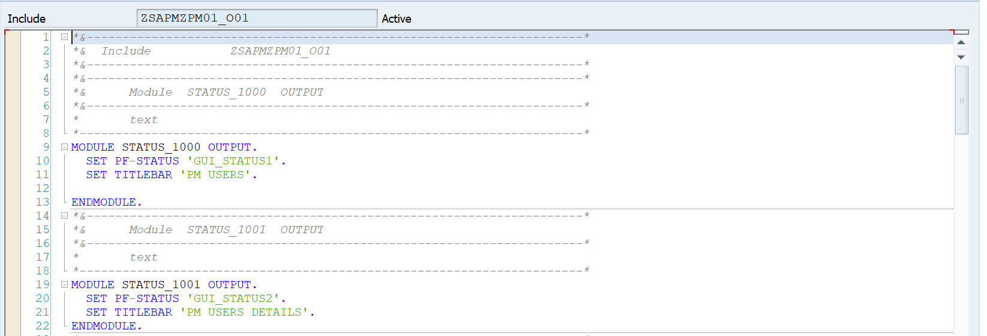

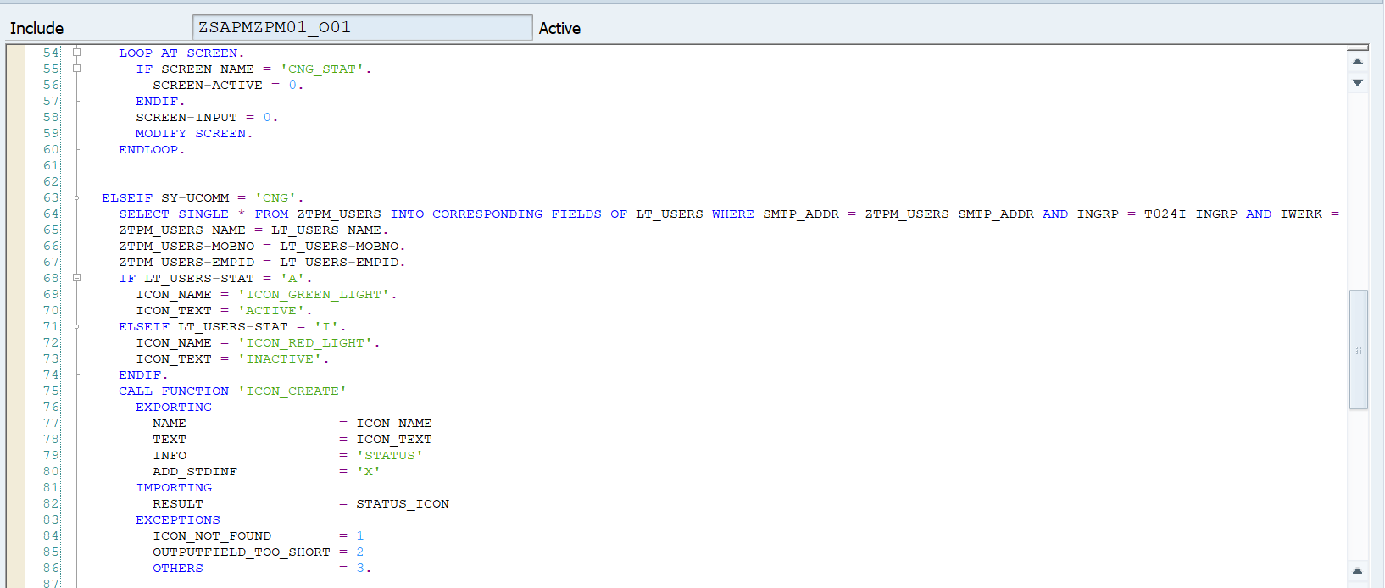



# Security [Mandatory]

**“The change does not use / create any new authorization objects. Therefore this is Not Applicable” else provide user role**

# Message handling

|  |  |  |  |
| --- | --- | --- | --- |
| Scenario | Message text | Type of message  (Error, Warning, Success) | Corrective Action if any |
|  | Email ID is not correct. | E |  |

# Impact Analysis: [Mandatory for all changes]

## Impact on processes including application controls: No GR document will be created once we save PO with unticked value in NON GR IV field

## Impact on data: No Impact

## Impact on end users: No need to create GR for two way match PO

## Impact on Interfaces with other systems: Ariba

## Impact on Operational procedures: No Impact

## Impact on Infrastructure: No Impact

## Impact on System / DB Admin: No Impact

# Test cases (State reasons if any of the testing is not applicable)

## Unit testing:

|  |  |  |
| --- | --- | --- |
| Test Case  Sl no. | Test Case Description | Expected Result |
|
|  |  |  |
|  |  |  |

## Integration testing:

NA – As this a technical change

## Interface testing:

NA – As this a technical change

## Volume/ Stress testing:

NA – As volume is not much

## Security testing:

NA – As there is no changes in security roles

## Data conversion testing:

NA – There is no conversion involved.

# Deployment Plan (Applicable for NON SAP application)

* Section 13 and 14 will be applicable only if FS is not there, else delete or use for Technical test cases if any